**ASSIGNMENT-1**

Create a blog or website using Blogspot and WordPress .Customize the theme design and post new article with 500 words.

|  |  |
| --- | --- |
| NAME | Jayapal.M |
| NM ID | 10BFD22FD91B9D5A6B649D2FCD4BB3F4 |
| ASSIGNMENT 1 | Create a blog or website using Blogspot and WordPress |

**Blog page link:**

https://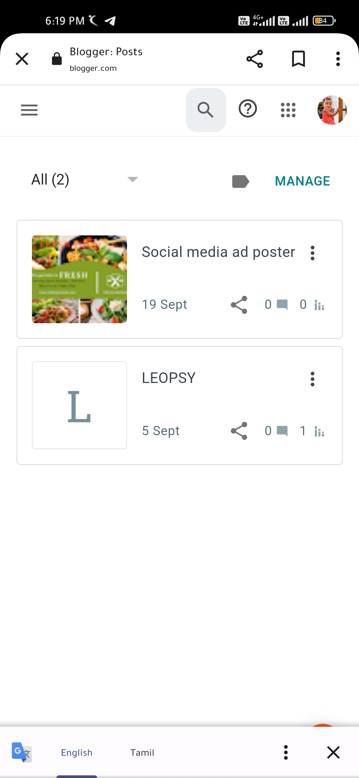www.blogger.com/blog/posts/8993326665400245507